Unsuccessful Test cases

A: Create Account (Email + Password)New user sign-up, form validation, profile setup, home location, onboarding
9. Click "Save Home Location →"Toast: "Home location saved!" Then the main map app loads. The loading splash ("Loading your map…") appears briefly. The app shows the onboarding welcome screen.
I saved the home location as my actual home in Arekere, Mico layout. On clicking the save button, it shows that the home location is saved now. But when it continues to the home page, it shows the home saved as Koramangala.

C: Password Reset Flow. Request reset email, confirm email arrives, click link, set new password, sign in with new password

4. Check the reset link goes to the UAT URL (not production)
Hover over or copy the link in the email. It should start with https://mapit-backend-git-uat-nagesh-n-arun.vercel.app NOT www.mapit.co.in.

The Reset link goes to production URL as shown below.

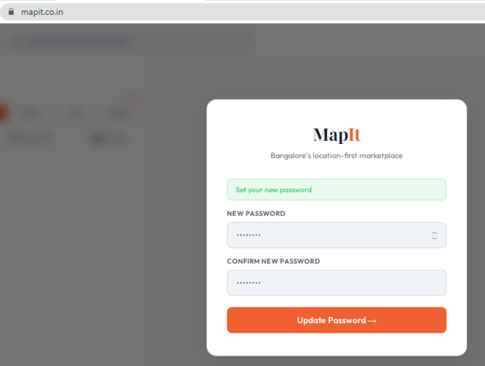

I:Google OAuth Sign-In
Continue with Google flow, redirect stays on UAT, profile setup for new Google users

3. New Google user → Profile Setup screen appears. If this Google account has never used MapIt before, the Profile Setup screen (Full Name, Nickname, ToS checkbox) appears. Name may be pre-filled from Google.

Before continuing to the home screen, the sign in page appears again briefly, which might confuse Users

